**ASSIGNMENT-2**

|  |  |
| --- | --- |
| **PROJECT NAME** | **CUSTOMER CARE REGISTRY** |
| **NAME** | **GORLA PENCHALA NARASIMHA** |
| **ROLL NO** | **4211191031018** |
| **TEAM ID** | **PNT2022TMID10783** |

1. **HTML CODE:**

|  |
| --- |
| <!DOCTYPE html> |
|  | <html> |
|  | <head> |
|  | <title>Table</title> |
|  | <link rel="stylesheet" href="table.css"> |
|  | </head> |
|  | <body> |
|  | <h1><p align="center"><b>FORM</b></p></h1> |
|  | <center> |
|  | <table border="4"> |
|  | <thead> |
|  | <tr> |
|  | <th>First Name</th> |
|  | <td><input type="text" name="fname" id="fname"></td> |
|  | </tr> |
|  | </thead> |
|  | <tbody> |
|  | <tr> |
|  | <th>Last Name</th> |
|  | <td><input type="text" name="lname" id="lname"></td> |
|  | </tr> |
|  | <tr> |
|  | <th>Gender</th> |
|  | <td><input type="radio" name="gender" id="gender" value="None">None |
|  | <input type="radio" name="gender" id="gender" value="Male">Male |
|  | <input type="radio" name="gender" id="gender" value="Female">Female |
|  | <input type="radio" name="gender" id="gender" value="Others">Others</td> |
|  |  |
|  | </tr> |
|  | <tr> |
|  | <th>Department</th> |
|  | <td><select name="DEPT" id="dept"> |
|  | <option value="NONE">NONE</option> |
|  | <option value="CSE">CSE</option> |
|  | <option value="IT">IT</option> |
|  | <option value="ECE">ECE</option> |
|  | <option value="EEE">EEE</option> |
|  | <option value="CIVIL">CIVIL</option> |
|  | <option value="MECHANICAL">MECHANICAL</option> |
|  | </select></td> |
|  | </tr> |
|  |  |
|  | <tr> |
|  | <th>Email</th> |
|  | <td><input type="email" name="email" id="email"></td> |
|  | </tr> |
|  | <tr> |
|  | <th>Password</th> |
|  | <td><input type="password" name="password" id="password"></td> |
|  | </tr> |
|  | <tr> |
|  | <th>Age</th> |
|  | <td><input type="text" name="age" id="age"></td> |
|  | </tr> |
|  | <tr> |
|  | <th>Address</th> |
|  | <td><textarea id="address"></textarea></td> |
|  | </tr> |
|  |  |
|  | <tr id="btna"> |
|  | <td colspan="2"><input type="button" name="button" id="btn" value="Add" onclick="AddRow()"></td> |
|  | </tr> |
|  | <tr> |
|  | <td ><a href="copage.html" target="_default"><button >SUBMIT</button> |
|  | </td> |
|  | </tr> |
|  | </tbody> |
|  | </table> |
|  |  |
|  | <table border="4" id="show"> |
|  | <thead> |
|  | <tr> |
|  | <th>First Name</th> |
|  | <th>Last Name</th> |
|  | <th>Gender</th> |
|  | <th>Department</th> |
|  | <th>Email</th> |
|  | <th>Password</th> |
|  | <th>Age</th> |
|  | <th>Address</th> |
|  |  |
|  | </tr> |
|  | </thead> |
|  | </table> |
|  | </center> |
|  |  |
|  | <script> |
|  |  |
|  | var list1 = []; |
|  | var list2 = []; |
|  | var list3 = []; |
|  | var list4 = []; |
|  | var list5 = []; |
|  | var list6 = []; |
|  | var list7 = []; |
|  | var list8 = []; |
|  |  |
|  | var n = 1; |
|  | var x = 0; |
|  |  |
|  | function AddRow(){ |
|  |  |
|  | var AddRown = document.getElementById('show'); |
|  | var NewRow = AddRown.insertRow(n); |
|  |  |
|  | list1[x] = document.getElementById("fname").value; |
|  | list2[x] = document.getElementById("lname").value; |
|  | list3[x] = document.getElementById("gender").value; |
|  | list4[x] = document.getElementById("dept").value |
|  | list5[x] = document.getElementById("email").value; |
|  | list6[x] = document.getElementById("password").value; |
|  | list7[x] = document.getElementById("age").value; |
|  | list8[x] = document.getElementById("address").value; |
|  |  |
|  |  |
|  | var cel1 = NewRow.insertCell(0); |
|  | var cel2 = NewRow.insertCell(1); |
|  | var cel3 = NewRow.insertCell(2); |
|  | var cel4 = NewRow.insertCell(3); |
|  | var cel5 = NewRow.insertCell(4); |
|  | var cel6 = NewRow.insertCell(5); |
|  | var cel7 = NewRow.insertCell(6); |
|  | var cel8 = NewRow.insertCell(7); |
|  |  |
|  | cel1.innerHTML = list1[x]; |
|  | cel2.innerHTML = list2[x]; |
|  | cel3.innerHTML = list3[x]; |
|  | cel4.innerHTML = list4[x]; |
|  | cel5.innerHTML = list5[x]; |
|  | cel6.innerHTML = list6[x]; |
|  | cel7.innerHTML = list7[x]; |
|  | cel8.innerHTML = list8[x]; |
|  |  |
|  |  |
|  | n++; |
|  | x++; |
|  | } |
|  |  |
|  | </script> |
|  | </body> |
|  | </html> |

**OUTPUT:**

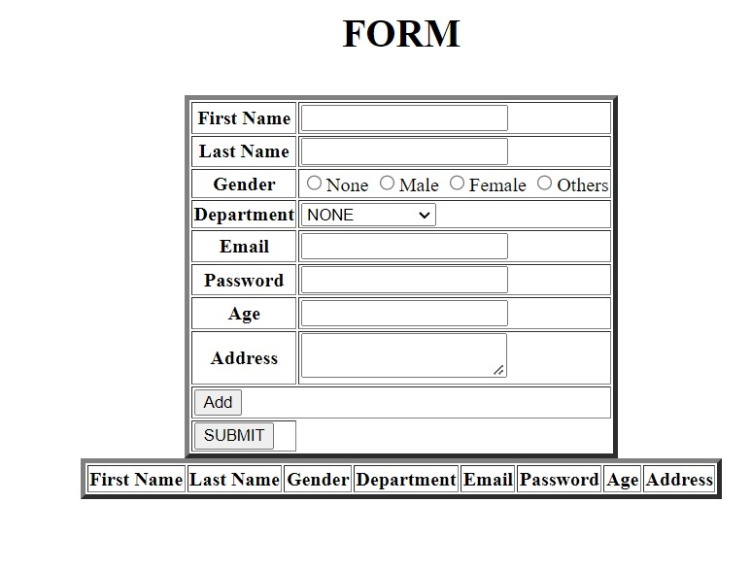

**2.CO-PAGE CODE:**

<!DOCTYPE html>

<html>

<head>

<title>Successful</title>

</head>

<body style="background-color:blue;">

<h1 align="center"><b>Your Data Has Been Stored And Registered Successfully!!</b></h1>

</body>

</html>

**OUTPUT:**

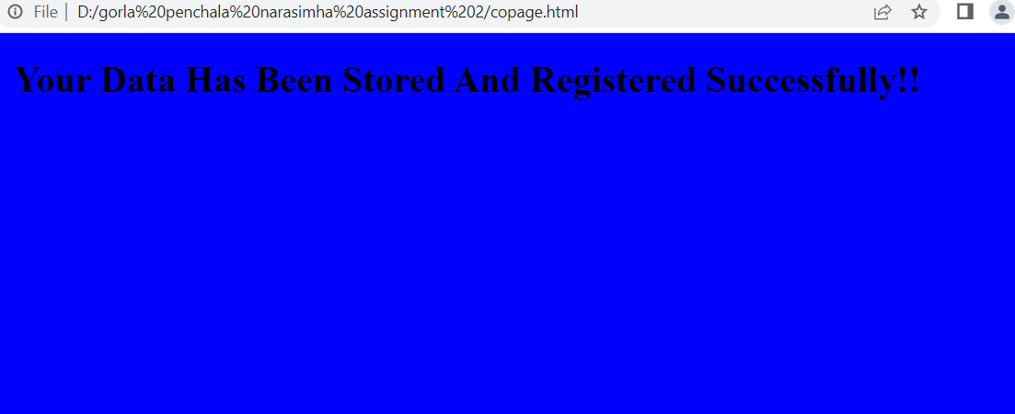

**3.CSS CODE:**

|  |  |
| --- | --- |
|  | table{ |
|  | margin-top: 50px; |
|  | text-align: center; |
|  | background: red; |
|  | color: #fff; |
|  | } |
|  |  |
|  | #show th, #show td{ |
|  | padding: 13px; |
|  | } |
|  |  |
|  | #btna td input{ |
|  | width: 100%; |
|  | } |

**OUTPUT:**

